**[IS113] Extra Exercises - Database Interaction**

**Resource Download**

* To download the **resource files**, go to: <https://smu.sg/hou>
* You will see folders (**q1**, **q2**, **q3, q4, q5, q6, q7**).
  + Download & place the folders inside **<web root>/is113/extra11/** on your local computer.

**Extra Exercises - Database Interaction (Set A)** can be accessed at: <https://smu.sg/hod>

**NOTE:** If you spot any mistakes/errors in the questions, please email the info to the following authors. In the email message, please be specific about what are the mistakes/errors.

|  |  |  |
| --- | --- | --- |
| **Question** | **Author** | **Contact Info** |
| 1 | David LO | davidlo@smu.edu.sg |
| 2 | Lay Foo THIANG | lfthiang@smu.edu.sg |
| 3 | Kyong SHIM | kjshim@smu.edu.sg |
| 4 | Yi Meng LAU | ymlau@smu.edu.sg |
| 5 | Shar LK | lkshar@smu.edu.sg |
| 6 | Yi Meng LAU | ymlau@smu.edu.sg |
| 7 | Kyong SHIM | kjshim@smu.edu.sg |

**Question 1: Person Filter ( Difficulty Level: * )**

**Given:**

* q1/model
  + ConnectionManager.php, Person.php (**complete**)
  + PersonDAO.php *(****partial****)*
* q1/
  + common.php (**complete**)
  + display.php *(****partial****)*
  + setup.sql (**complete**)

Read and use the given setup.sql to understand and create the necessary database and tables for this question.

**Part A: Complete search method of "PersonDAO.php"**

Complete **search** method of **PersonDAO.php** page to retrieve all persons from **person** table that satisfy the search criteria (minimum age, maximum age, and gender).Return all matching persons as an indexed array of **Person** objects. If Part A is completed well, the following would be the behavior when **display.php** is opened in the web browser:

*When the page loads for the first time:*

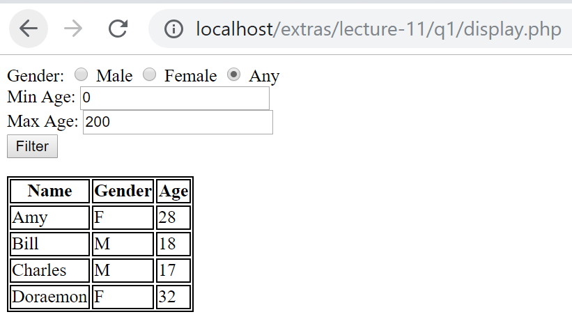

*When one or more search criteria are specified and* ***Filter*** *submit button is clicked:*

*(i) search criteria are specified*

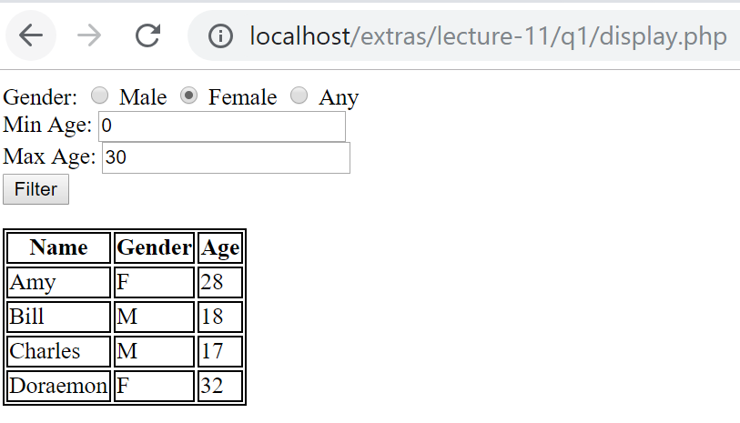

*(ii) output*

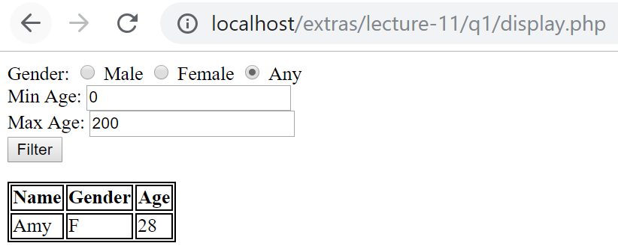

**Part B: Complete "display.php"**

Complete display.php so that the page remembers the values that the user selects before the **Filter** button is clicked. If Part B is completed well, the following would be the behavior when display.php is opened on the web browser:

*(i) search criteria are specified*



*(ii) output*

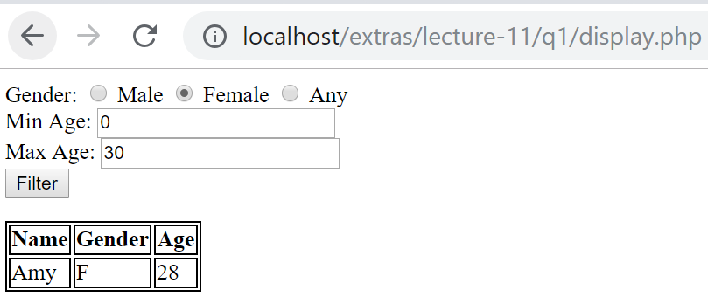

**Question 2: Warehouse ( Difficulty Level: ** )**

**Given:**

q2/

* create.sql
* style.css
* ConnectionManager.php, Product.php, Warehouse.php
* categoryList.php
* searchByCategoriesAndPriceRange.php
* searchByCategory.php
* searchByPriceRange.php
* testGetCategories.php
* testSearchByCategory.php
* testSearchByPriceRange.php

**[1]**Read and use the given **create.sql** to understand and create the necessary database and tables for this question.

**Part A**

Update class Warehouse to implement its method getCategories() to

1. Retrieve the list of product categories from database table category
2. Return the product categories as an indexed array of strings sorted alphabetically (case-sensitive) in ascending order

If done correctly, testGetCategories.php should display the following:

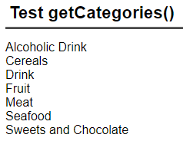

**Part B**

Create class Product

1. Four properties: Product name : String, Category name : String, Quantity : Integer, Price : Float
2. Constructor that takes in 4 parameters to initialize its properties.
3. Getter methods for its properties.

Update class Warehouse to implement its method searchByCategory($category_name) to

1. Parameter
   1. $category_name is the product category to search for
2. Return an indexed array of Product objects representing products for the specified category sorted by products' name alphabetically (case-sensitive) in ascending order.

If done correctly, testSearchByCategory.php should display the following: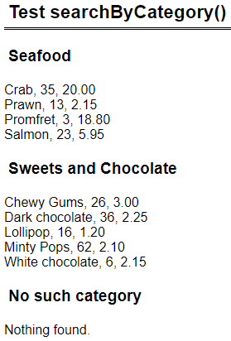

**Part C**

Edit searchByCategory.php such that it has a form with

1. A drop down list of product categories retrieved using class Warehouse’s method getCategories().
2. Button ‘Search’ that submits the form back to itself (same page) via HTTP GET.

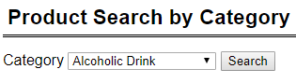

Upon form submission, the page does the following:

1. The drop down list should show the category that user has selected.
2. Retrieves all products of the specified category using class Warehouse’s method searchByCategory($category_name).
3. Display details of the products as shown in the table below sorted by products' name alphabetically (case-sensitive) in ascending order.
4. For quantity,
   1. If quantity is less than 10, display quantity in red.
   2. If quantity is less than 20, display quantity in orange.
   3. Otherwise, black.
   4. Look at the given searchByCategory.php for the CSS code for text color.

If done correctly, when user searches for category ‘Sweets and Chocolate’, the page should look like this:

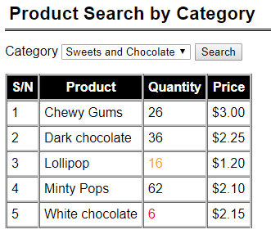

**Part D**

Update class Warehouse to implement its method searchByPriceRange($min_price, $max_price) to

1. Parameters
   1. $min_price (float) is the minimum price to search for
   2. $max_price (float) indicate the price range to search for.
2. You may assume that $min_price is less than or equal to $max_price.
3. Return an indexed array of Product objects whose price is between $min_price and $max_price inclusive. The products are sorted by **price, then product’s name** alphabetically (case-sensitive) in ascending order.

If done correctly, testSearchByPriceRange.php should display the following:

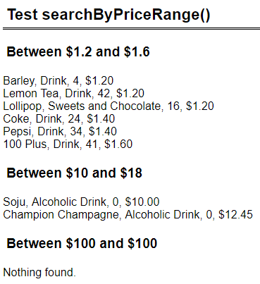

**Part E**

Edit searchByPriceRange.php such that it has a form with

1. Text field ‘Min price’ with default value 0.
2. Text field ‘Max price’ with default value 100.
3. Button ‘Search’ that submits the form back to itself (same page) via HTTP GET.

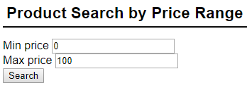

You may assume that user will always enter valid floating numbers for min and max prices, and min price is less than or equal to max price.

Upon form submission, the page does the following:

1. The two text fields should show the values that user has entered.
2. Retrieves all products whose price is between min and max prices inclusive.
3. Display details of the products as shown in the table below sorted by **price, then product’s name** alphabetically (case-sensitive) in ascending order.
4. Do the same color coding for quantity as part C.

If done correctly, when user searches for prices between 1.2 and 1.6 inclusive, the page should look like this:

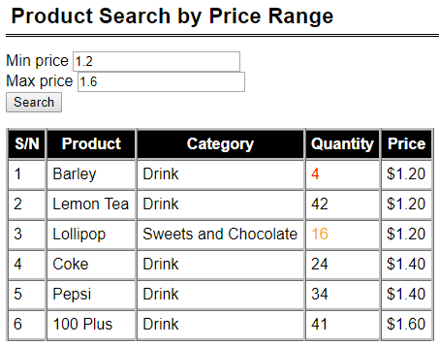

When user searches for prices between 1.2 and 1.6 inclusive, the page should look like this:

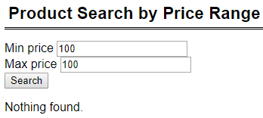

**Part F**

Update categoryList.php to display an ordered list of the product categories. Each category name is linked to searchByCategory.php. Upon clicking the category-name-hyperlink, searchByCategory.php should display the products for that category.

If done correctly, the page looks like this:

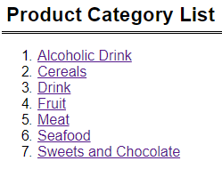

If user clicks on ‘Seafood’, the browser goes to searchByCategory.php (screenshot below) and displays ‘Seafood’ (as though user had selected ‘Seafood’ from the drop down list).

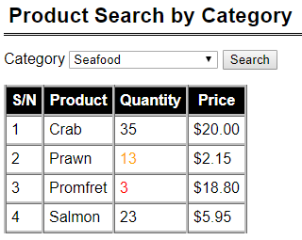

**Part G**

Update class Warehouse to implement its method searchByCategoriesAndPriceRange($category_name, $min_price, $max_price) to

1. Parameters
   1. $category_names is an indexed array of strings representing the categories to search for
   2. $min_price (float) is the minimum price to search for
   3. $max_price (float) indicate the price range to search for.
2. You may assume that $min_price is less than or equal to $max_price.
3. Return an **associative array.**
   1. Key is product category name
   2. Value is an indexed array of Product objects for the specified category and whose price is between $min_price and $max_price inclusive. The products are sorted by **category name then product's name** alphabetically (case-sensitive) in ascending order.

Edit searchByCategoriesAndPriceRange.php such that it has a form with

1. A list of checkboxes for the product categories.
2. Text field ‘Min price’ with default value 0.
3. Text field ‘Max price’ with default value 100.
4. Button ‘Search’ that submits the form back to itself (same page) via HTTP GET.

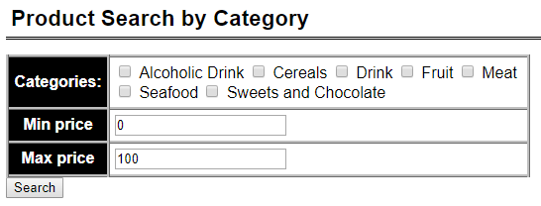

You may assume that user will always enter valid floating numbers for min and max prices, and min price is less than or equal to max price.

Upon form submission, the page does the following:

1. The form should show the values that user has selected or entered.
2. Retrieves all products for the specified category and whose price is between min and max prices inclusive.
3. Display details of the products as shown in the table below sorted by category name then product's namealphabetically (case-sensitive) in ascending order.
4. Do the same color coding for quantity as before.

If done correctly, sample screenshots of the page:

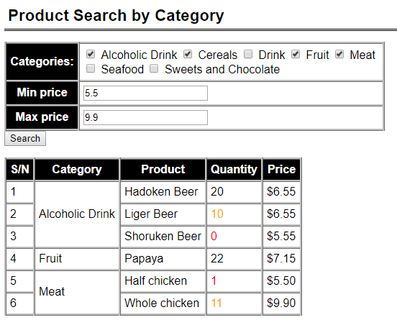

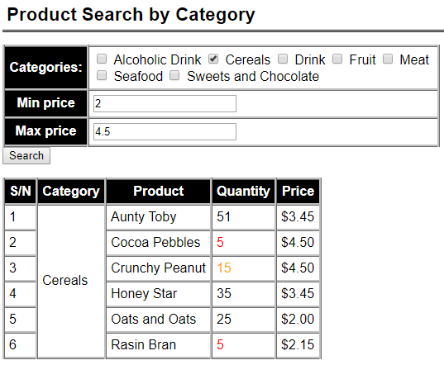

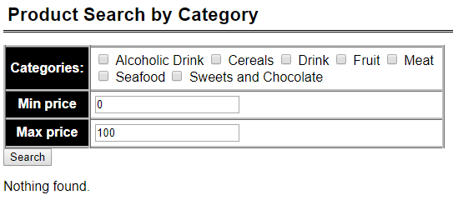

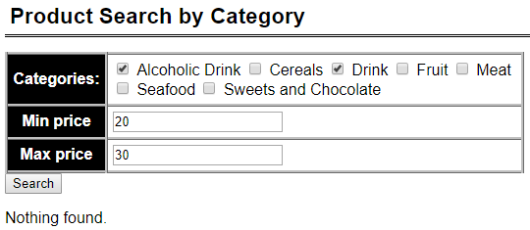

**Question 3: KPop Stars ( Difficulty Level: ** )**

**Given:**

q3/

* ConnectionManager.php, common.php, create.sql
* Star.php, StarDAO.php
* display.php, edit.php, update.php
* images/* (there are FOUR (4) JPG image files)

Read and use the given **create.sql** to understand and create the necessary database and tables for this question.

* Open create.sql. Take the SQL statements in this file and execute it (you may use **WorkBench** or **PHPMyAdmin**, whichever one you are comfortable with).
* It creates a schema **kpop**. Inside **kpop**, it creates a table **star**.

**Part A ( Difficulty: ** )**

Edit display.php such that it:

* Uses **StarDAO object** to query the database table **star** via public method **getAll()**, which returns an Indexed Array of **Star objects**.
* Receives an Indexed Array of **Star objects** and displays the stars’ information in an HTML table.

|  |
| --- |
| **display.php** |
|  |

The last table column **“Edit Link”** must display a HyperLink to page **edit.php**.

* The HyperLink URL will look like this: **edit.php?id=2**
* Clicking on this link will make a new HTTP GET request to **edit.php** with one parameter with the name **id**. The value (e.g. **2** in the above example) is a particular star’s **id** (as retrieved from the database). Your code can obtain this **id** from each **Star object** via public Getter method **getID()**.

**Part B ( Difficulty: ** )**

Suppose that the user clicks on **Seolhyun**’s **Edit** HyperLink. The user will be taken to **edit.php** with a particular **id**, e.g. **2** (this is the **ID** of **Seoulhyun** in my local MySQL database table **star**).

* Link: **edit.php?id=2**

Edit edit.php such that it:

* Retrieves the value of the parameter **id** from HTTP GET request.
* Takes this **id** value and calls **StarDAO** object’s public method **getStarByID($id)**. This method is defined in **StarDAO.php**. Please go and have a look at the method. ***What does it do?***
  + It retrieves a row from the database table **star** where the **id** column value matches that of the method parameter **$id**.
  + If a matching row is found in table **star**, this method retrieves all column data and create a new **Star** **object**. This **Star** **object** is then returned to **edit.php**.
* Takes the **Star** **object** and displays the star’s information as shown below:

|  |
| --- |
| **edit.php?id=2** |
|  |

* Only ONE (1) property (or attribute) is **editable**.
  + **Headline** text can be updated by the user.
* **Name** and **Gender** cannot be updated via this webpage. Hence, we display them as text (without editable input fields).
* Upon keying in new data for **Headline** input field (text), the user clicks on the SUBMIT button “Update Info”. It will then submit to **update.php** via HTTP POST method.
* Please see additional guiding comments inside **edit.php** for further instructions.

**Part C ( Difficulty: ** )**

*(Continuing with* ***Part B*** *example)*

Suppose that the same user clicks on “Update Info” SUBMIT button. It submits to **update.php**.

Edit update.php such that it:

* Retrieves the value of the parameter **id** AND the parameter **headline** from HTTP POST request.
* Calls **StarDAO** object’s public method **updateHeadline($id, $headline)**. This method is defined in **StarDAO.php**. Please go and have a look at the method. ***What does it do?***
  + It updates the table (**star**) **row** where the row’s **id** column value matches that of the method parameter **$id**. Specifically, it updates the value of the column **headline** in the matching row.
  + If the query executes successfully, then the method will return **Boolean True**.
  + Else, it will return **Boolean False**.
  + How do you check if **query** ran **successfully**?
    - See what **$stmt->execute()** returns. Does it return a Boolean value?

**BEFORE editing the “Headline” text**

|  |
| --- |
| **edit.php?id=2** |
|  |

**AFTER editing the “Headline” text**

|  |
| --- |
| **edit.php?id=2** |
|  |

**AFTER clicking on the “Update Info” SUBMIT button in edit.php**

|  |
| --- |
| **update.php** |
|  |

**AFTER clicking on the HyperLink** here

**display.php** shows the updated “Headline” text for Seolhyun (3rd row of the HTML table)

|  |
| --- |
| **display.php** |
|  |

**Question 4: Location and Store Filter ( Difficulty Level: * )**

**Given:**

* q4/model
  + ConnectionManager.php, Product.php Shop.php (**complete**)
  + ProductDAO.php *(****partial****)*
  + ShopDAO.php *(****partial****)*
* q4/
  + common.php (**complete**)
  + display.php *(****partial****)*
  + setup.sql *(****run this before you start)***

The page allows the user to select a location and a shop name. These values are retrieved from the database and should not be hardcoded. The list of location and shop names are distinct, i.e. there should not be any duplicates. With these inputs, the application will proceed to check if the selected shop name exists at the selected location. If it does, it will returns a list of products that are available by the shop. You can assume that a shop can which exists in multiple locations, offering similar products. There are exceptional cases where the shop exists at the selected location but does not offer any products at this point of time.

**NOTE**: The suggested solution does not uses join tables in the SQL statements.

**Part A: Complete "ProductDAO.php and ShopDAO.php"**

Complete functions to retrieve the distinct list of locations, distinct list of shop names and list of products available at a shop. Return all matching data from ProductDAO.php as an indexed array of Product objects. The return of data from ShopDAO.php can be in the form of either an indexed array of Shop objects or strings.

**Part B: Complete "display.php"**

Complete display.php so that the page remembers the values that the user selects before the **Submit** button is clicked. If Part B is completed well, the following would be the behavior when display.php is opened on the web browser:

The following would be the behavior when display.php is opened in the web browser:

* *When the page loads for the first time, the distinct list of locations and shop names are provided in the drop down list. If nothing is selected, the default will be the first in the list:*

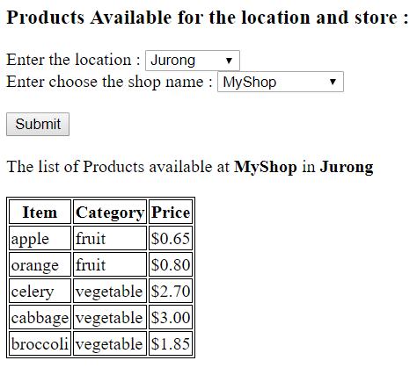

* *When the user selects a location and a shop name, the application will do a check. If the shop exists in the location but does not have any available products, the page will display the following:*

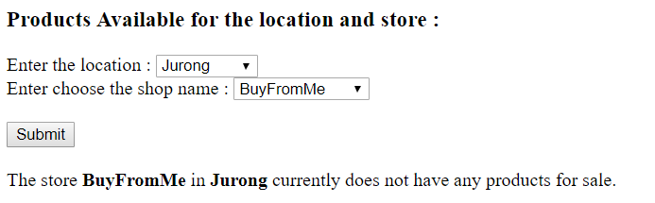

* *When the user selects a location and a shop name, the application will do a check. If the shop does not exist in the selected location, the page will display the following:*

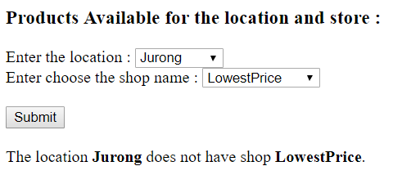

**Question 4b: Location and Store Filter Using Indexed Array within the Shop Class**

**( Difficulty Level: ** )**

**Copy the following files from Question 4 into the following drive:**

* q4/model
  + ConnectionManager.php (no changes required)
  + Product.php (no changes required)
  + ProductDAO.php (no changes required)
  + Shop.php (***changes required as below***)
  + ShopDAO.php *(may need modifications****)***
* q4/
  + common.php (no changes required)
  + display.php *(****changes required)***
  + setup.sql *(run this if you need to refresh your*

*database)*

In this version, the class Shop will have three properties – the shop name, the shop location and an indexed array of products sold by the shop. The indexed array will consist of Product objects which can be retrieve from the database by calling the ProductDAO class at the constructor. The modifications will be in the constructor.

The class Shop will looks like this:

|  |
| --- |
| class Shop{  private $name;  private $location;  private $items;  // this is an indexed array of Product objects.  public function __construct ($name, $location) {  $this->name = $name;  $this->location = $location;  // Use of ProductDAO to retrieve the list of products  // available at the store.  $dao = new ProductDAO();  ... /* enter your codes here */  }  . . . // the rest of the codes do not need changes  } |

Make the appropriate modifications of the codes in Shop.php, ShopDAO.php and display.php such that it is able to make use of the updated class Shop. The codes in display.php will only need to call ShopDAO objects. The behavior of display.php is the same as Question 4.

**Question 5: Employment Statistics ( Difficulty Level: ** )**

**Given:**

q5/

● model/populateDatabase.php **(complete)**

● model/ConnectionManager.php (**complete)**

● model/EmploymentStat.php ***(partial)***

● model/EmploymentStatDAO.php ***(partial)***

● common.php **(complete)**

● viewEmployment.php ***(partial)***

● updateEmployment.php ***(partial)***

● viewEmploymentB.php ***(partial)***

**Part A: Run populateDatabase.php**

Run populateDatabase.php from your localhost to create employmentstat table in the existing week11extras database.

(note: populateDatabase.php accesses the statistics provided by<https://data.gov.sg/dataset/graduate-employment-survey-ntu-nus-sit-smu-sutd> via an API and loads them into employmentstat table)

If done correctly, you should see some records in employmentstat table as follows:

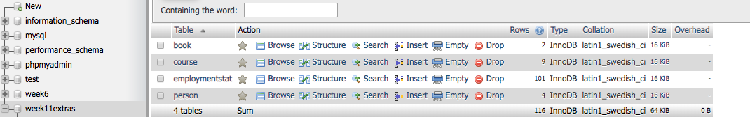

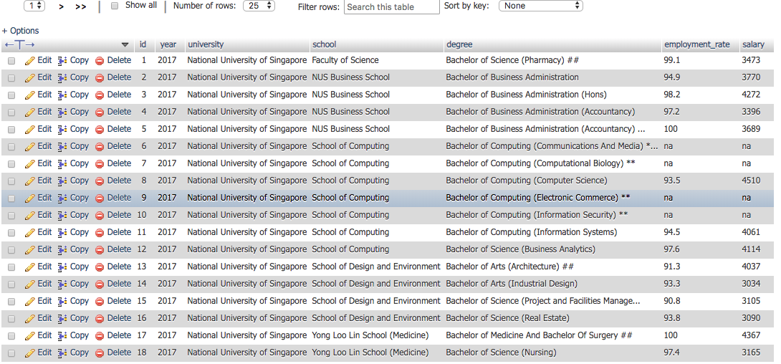

**Part B: Create class EmploymentStat**

1. Seven properties: id : Integer, year : Integer, university: String, school : String, degree : String, employment_rate : Float, avgSalary: Integer
2. Constructor that takes in 7 parameters to initialize its properties.
3. Getter methods for its properties.

**Part C: Complete retrieveAll method of EmploymentStatDAO.php**

Complete **retrieveAll** method of **EmploymentStatDAO.php** to retrieve all employment statistics from **employmentstat** table.Return the employment statistics data as an indexed array of **EmploymentStat** objects.

If done correctly, the following would be the behavior when **viewEmployment.php** is opened in the web browser:

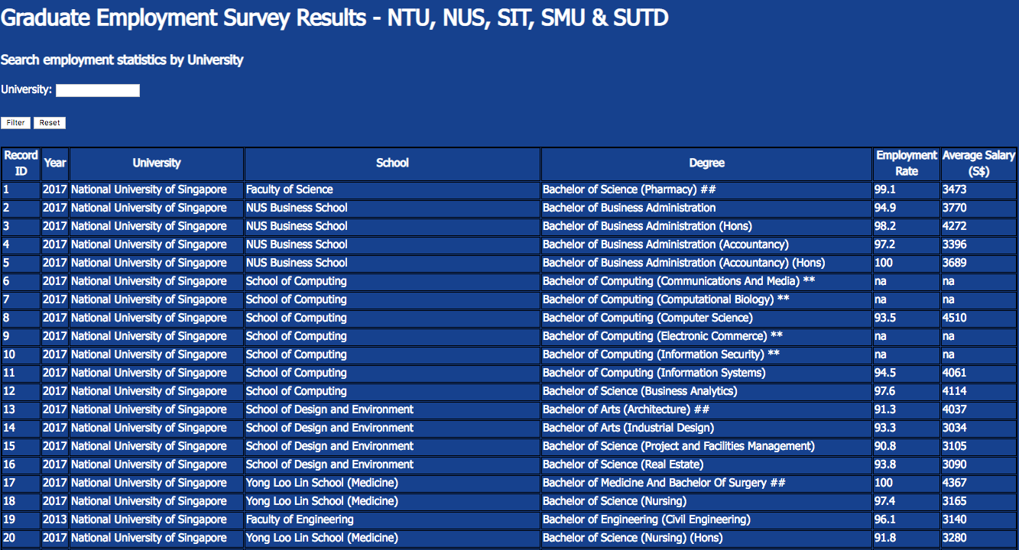

**Part D: Implement SearchByUniversity functionality**

1. Complete **searchByUniversity** method of **EmploymentStatDAO.php** to retrieve the employment statistics of **a given university** from **employmentstat** table.Return the employment statistics data as an indexed array of **EmploymentStat** objects.

2. Complete **viewEmployment.php** by adding code to read the **university** input from the user and retrieve the employment statistics of that university, by using the **searchByUniversity** method implemented above.

3. Upon clicking the **Filter** button in **viewEmployment.php**, it should display the employment statistics of a given university. Upon clicking the **Reset** button, it should display back all the employment statistics of all the universities.

Your code should handle possible exceptions and invalid scenarios, such as errors in accessing the database, clicking the Filter button without entering the university value, entering an invalid university value, etc.

If done correctly, the following would be the behavior when **viewEmployment.php** is run in the web browser:

*Entering the university input as “Singapore Management University”:*



*Upon clicking Filter button:*

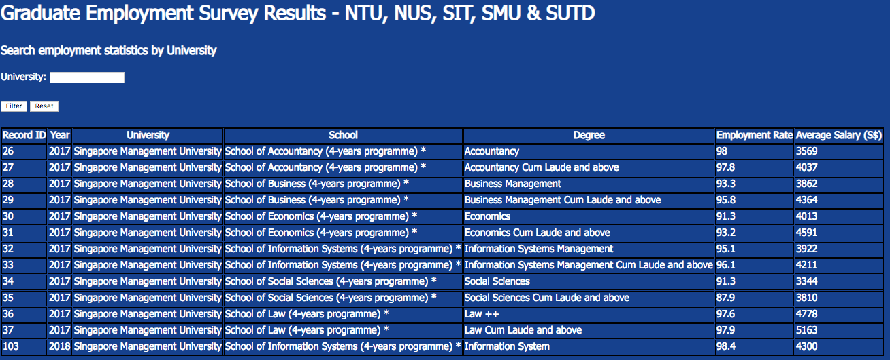

*Upon clicking Reset button:*

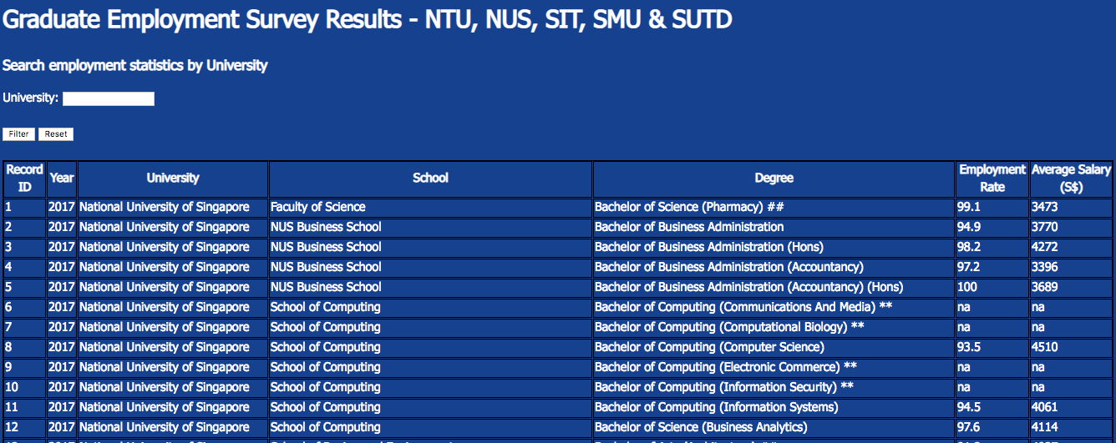

**Part E: Implement Create, Update, and Delete Employment Statistics functionality**

1. Complete **add** method of **EmploymentStatDAO.php** to insert a new employment statistics into the **employmentstat** table.Return the Boolean value “TRUE” if insert operation is successful.

2. Complete **update** method of **EmploymentStatDAO.php** to update the **employment_rate** and **salary** of an existing employment statistics record in the **employmentstat** table, given its **id**.Return the Boolean value “TRUE” if update operation is successful.

3. Complete **delete** method of **EmploymentStatDAO.php** to delete an existing employment statistics record in the **employmentstat** table, given its **id**.Return the Boolean value “TRUE” if update operation is successful.

Your code should handle possible exceptions and invalid scenarios, such as errors in accessing the database, entering invalid values, etc.

If done correctly, the following would be the behavior when **updateEmployment.php** is run in the web browser:

*Loading* **updateEmployment.php** *for the first time:*

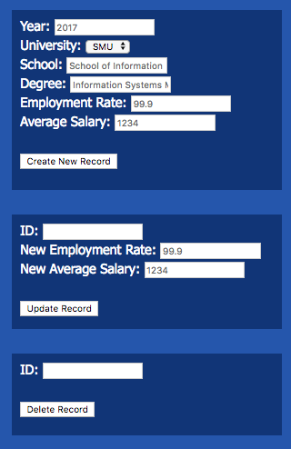

*Creating a new employment statistics: Upon clicking “Create New Record”:*

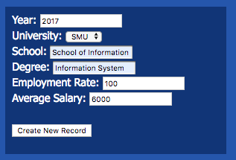 

*Updating an employment statistics: Upon clicking “Update Record”:*

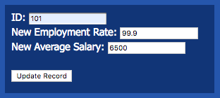 

*If create and update operations are successful, some changes should be observed in the employmentstat table in the database:*

*Deleting an existing employment statistics: Upon clicking “Delete Record”:*

* *

*In the employmentstat table in the database, record with id “101” should be deleted.*

**Part F: Implement computing average employment rate and salary of each university and each school**

1. Complete **viewEmploymentB.php** such that by default (when the page loads the first time or when the user clicks the **Reset** button), it displays the average salary and employment rate of each university.

2. Complete **viewEmploymentB.php** such that when the user provides a university input, it should display the average salary and employment rate of each school in that university.

If done correctly, the following would be the behavior when **viewEmploymentB.php** is run in the web browser:

*Loading* **viewEmploymentB.php** *for the first time:*



*Entering the university input as “Singapore Management University”:*



*Upon clicking the Filter button:*

**

*Upon clicking the Reset button:*

**

**Question 6: Maintain a Restaurant Menu ( Difficulty Level: ** )**

**Given:**

* q6/model
  + ConnectionManager.php, Food.php (**complete**)
  + FoodDAO.php *(****partial****)*
* q6/
  + common.php (**complete**)
  + maintain_menu.php (**partial**)
  + edit.php *(****partial****)*
  + delete.php *(****partial****)*
  + setup.sql *(****run this before you start)***

This exercise allows you to maintain the Food Menu at IS113 Kiosk. This application make use of three php programs to provide an interface for the user to maintain the set of data in the database. The primary key for each food item is defined as the Stock-Keeping-Unit (SKU in short) of type integer. The use of an SKU will identify a unique record from the database. The database also keeps track of the description, category and price of the SKU.

**Part A: Complete "FoodDAO.php"**

Complete functions in FoodDAO.php to perform the following:

* retrieve all records of food items that are offered, sorted by SKU. The method will return an indexed array of Food objects.
* retrieve a single record identified by the SKU the user input. The method will return a Food object.
* update single record in the database for the SKU selected by the user The method will return a status.
* delete a single record in the database for the SKU selected by the user The method will

**Part B: Complete "maintain_menu.php", “edit.php”, “delete.php”**

* *The maintain_menu.php will serve as the landing page of the application. There are two parts. At the top, it will display a snapshot of what are the food items available in the database, together with the description and prices. For each record, it will have a link should the user wants to edit or delete the record.*
* *After that, there is an interface which will allow the user to create new food items.*
* *The following would be the behavior when maintain_menu.php is opened in the web browser:*

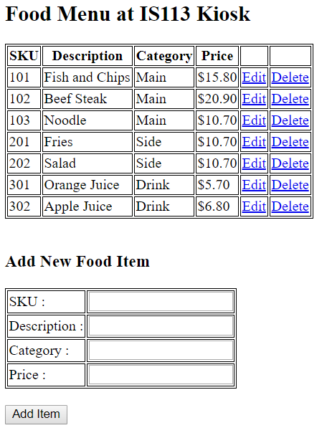

* *A user can add a new food item by keying in all the values and click on* ***Add Item****.*

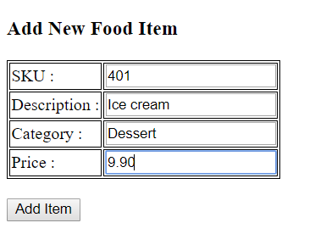

* *Upon successful creation of the new record. The menu is refreshed and the successful statement is provided. The*

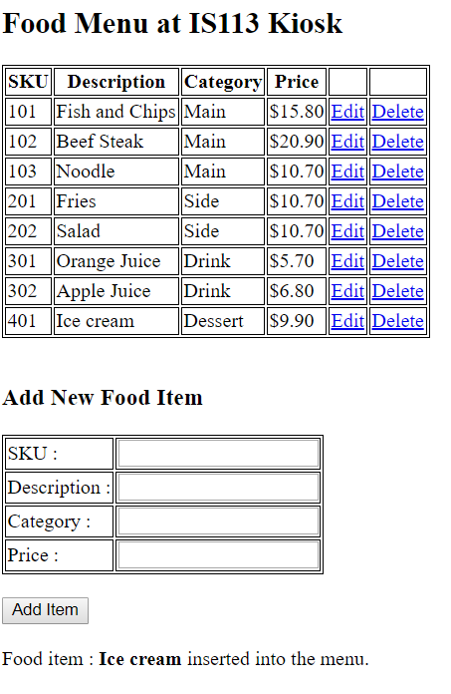

* *If the user enters a set of values but with the same SKU. The error message will be shown.*

*For example, if the user enters*

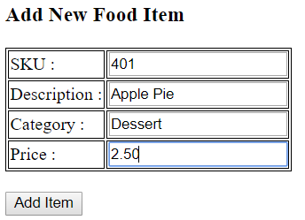

*Upon clicking Add Item, the screen will show*

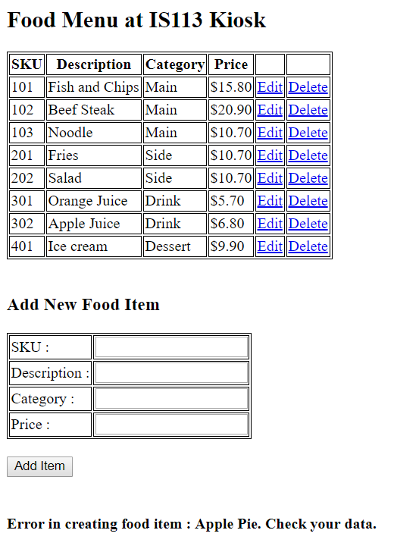

* *To edit a record, click on the Edit link. The following will be the display. The user will only be able to update the description, category and price. To complete the update, click on ‘Update Info’. A link is provided at the end of the page to return to the landing page.*

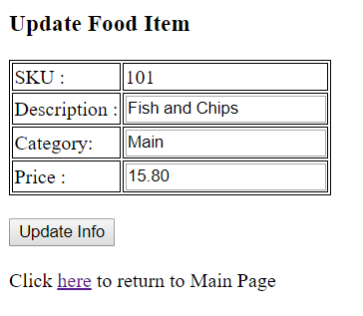

* *A successful update will show the following :*

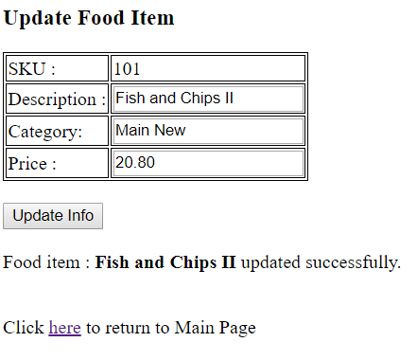

* *To delete a record, click on the Delete link from maintain_menu.php. The details of the item will be displayed. Click on Confirm to delete the item.*

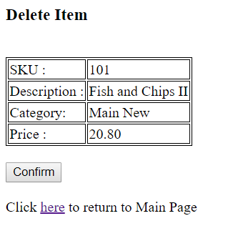

* *A successful delete will show the following :*

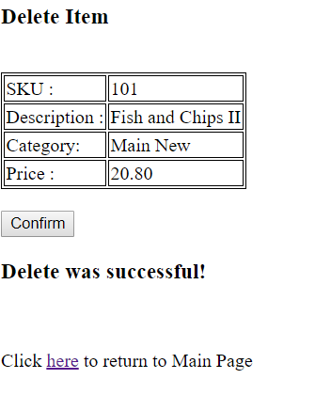

**Question 7: Blog Posts ( Difficulty Level: ** )**

**Given:**

* q7/database
  + create.sql
* q7/model
* ConnectionManager.php
* Post.php
* PostDAO.php
* q7/
* common.php
* add.html
* add.php
* delete.php
* edit.php
* update.php
* display.php

Read and use the given **create.sql** to understand and create the necessary database and tables for this question.

|  |
| --- |
| **create.sql** |
| ...  create table post (  id integer auto_increment primary key,  create_timestamp datetime,  update_timestamp datetime,  subject varchar(100),  entry text,  mood varchar(30)  );  ... |

* **id** is an internal (to MySQL database table post) ID
  + It is auto-generated and auto-incremented by the MySQL database.
  + Users or you (developer) do NOT need to manually add **id** data when insert new rows.
* **create_timestamp**
  + Indicates the datetime of data (row) insertion.
  + Any new blog posts being added to the **post** table via your web application will have **CURRENT_TIMESTAMP** as the default value. See **CURRENT_TIMESTAMP** below.
  + For more information, please check out: <https://www.w3schools.com/sql/func_mysql_current_timestamp.asp>
  + For example:

|  |
| --- |
| INSERT INTO post  (  create_timestamp,  update_timestamp,  subject,  entry,  mood  )  VALUES  (  **CURRENT_TIMESTAMP**,  **CURRENT_TIMESTAMP**,  'I hate school',  'I do not want to go to school',  'Sad'  ) |

* **update_timestamp**
  + Indicates the timestamp of data (row) update.
  + Any new blog posts being added to the **post** table via your web application will have **CURRENT_TIMESTAMP** as the default value. See **CURRENT_TIMESTAMP** above.
  + When a particular **post** is updated (e.g. subject/entry/mood change) via your web application, your code must also update **update_timestamp** by setting it to **CURRENT_TIMESTAMP**.
  + This way, we can capture in the MySQL database … when was the last time a particular **post** was updated.

**Part A ( Difficulty: ** )**

Edit **display.php** such that it:

* Uses **PostDAO object** to query the database table **post** via public method **getAll()**, which returns an Indexed Array of **Post objects**.
* Receives an Indexed Array of **Post objects** and displays the posts’ details in an HTML table.

|  |
| --- |
| **display.php** |
|  |

1. The table column **“Edit Link”** must display a HyperLink to page **edit.php**.
   1. The HyperLink URL will look like this: **edit.php?id=1**
   2. Clicking on this link will make a new HTTP GET request to **edit.php** with one parameter with the name **id**. The value (e.g. **1** in the above example) is a particular post’s **id** (as retrieved from the database). Your code can obtain this **id** from each **Post object** via public Getter method **getID()**.
2. The table column **“Delete Link”** must display a HyperLink to page **delete.php**.
   1. The HyperLink URL will look like this: **delete.php?id=1**
   2. Clicking on this link will make a new HTTP GET request to **delete.php** with one parameter with the name **id**. The value (e.g. **1** in the above example) is a particular post’s **id** (as retrieved from the database). Your code can obtain this **id** from each **Post object** via public Getter method **getID()**.
3. “**Add a New Blog Post**” at the bottom of the page is a HyperLink to page **add.html**.

**Part B ( Difficulty: ** ) EDIT**

In display.php, suppose that the user clicks on the **first post**’s **“Edit”** HyperLink.



The user is taken to **edit.php** with a particular **id**, e.g. **1** (this is the **ID** of the **first post** in my local MySQL database table **post**).

Edit edit.php such that it:

* Retrieves the value of the parameter **id** from HTTP GET request.
* Takes this **id** value and calls **PostDAO** object’s public method **get($id)**. This method is partially implemented in **PostDAO.php**.
  + **Complete this method** such that it retrieves a row from the database table **post** where the **id** column value matches that of the method parameter **$id**.
  + If a matching row is found in table **post**, this method retrieves all column data and create a new **Post** **object**. This **Post** **object** is then returned to **edit.php**.
* **edit.php** takes this **Post** **object** and displays the post’s details as shown below:

|  |
| --- |
| **edit.php?id=1** |
|  |

* The user should be able to key in new data for:
  + **subject**
  + **entry**
* The user should be able to select new **mood** (drop-down list).

Upon keying in or selecting new data:

* The user clicks on the SUBMIT button “Update Info”.
* The form will submit to **update.php** via HTTP POST method.

**Part C ( Difficulty: ** ) UPDATE**

*(Continuing with* ***Part B*** *example)*

Suppose that the same user clicks on “Update Info” SUBMIT button. It submits to **update.php**.

Edit update.php such that it:

* Retrieves the following from HTTP POST request.
  + **id**
  + **subject**
  + **entry**
  + **mood**
* Calls **PostDAO** object’s public method **update($id, $subject, $entry, $mood)**.
  + This method is defined in **PostDAO.php**. This method is partially implemented.
  + **Complete this method** such that:
    - It updates the table (**post**) **row** where the row’s **id** column value matches that of the method parameter **$id**. It must update **update_timestamp, subject, entry, mood**.
    - If the query executes successfully, then the method will return **Boolean True**.
    - Else, it will return **Boolean False**.
    - How do you check if **query** ran **successfully**?
      * See what **$stmt->execute()** returns. Does it return a Boolean value?
      * Query failed?
        + Try **var_dump**-ing **$stmt->errorinfo()** and see what it shows.

**BEFORE editing**

|  |
| --- |
| **edit.php?id=1** |
|  |

**AFTER editing the “subject” text and “entry” text**

|  |
| --- |
| **edit.php?id=1** |
|  |

**AFTER clicking on the “Update Info” SUBMIT button in edit.php**

|  |
| --- |
| **update.php** |
|  |

**AFTER clicking on the HyperLink** here

**display.php** shows the updated “Subject” text for the first post (1st row of the HTML table)

Do you also notice **“Last Update Timestamp”** reflects a new **timestamp**?

|  |
| --- |
| **display.php** |
|  |

Click on **Edit** HyperLink and let’s check to see if all details were updated correctly.

**edit.php** correctly displays all new data.

|  |
| --- |
| **edit.php?id=1** |
|  |

**Part D ( Difficulty: ** ) DELETE**

*Remember the guy that asked me out on Valentine’s Day?*

*DUH! He dumped me. So, I want to erase him from my blog FOREVER! -_-;*

In display.php, suppose that the user clicks on the **“Delete”** HyperLink.



The user is taken to **delete.php** with a particular **id**, e.g. **5** (this is the **ID** of the **last post** in my local MySQL database table **post**).

Edit delete.php such that it:

* Retrieves the value of the parameter **id** from HTTP GET request.
* Takes this **id** value and calls **PostDAO** object’s public method **get($id)**.
  + **You should have completed this method’s implementation in Part B**.
* **delete.php** takes the **Post** **object** returned by **get($id)**. It displays the post’s details as shown below:

|  |
| --- |
| **delete.php?id=5** |
|  |

* The user clicks on the SUBMIT button “Confirm Delete”.
* The form will submit to **delete.php** via HTTP POST method.
* The form has ONE (1) **hidden** input inside the FORM:

|  |
| --- |
| <input type='hidden' name='id' value='5'> |

* It is hidden - such that it does not display in the web browser.
  + *View Source will show the above HTML though.*
* Hidden input fields are submitted as part of form submission.

Upon “Confirm Delete”, the page displays:

|  |
| --- |
| **delete.php** |
|  |

So what’s going on in **delete.php**?

* It uses a **PostDAO** object to call its public method **delete($id)**. This method is partially implemented.
  + **Complete this method** such that it deletes a row from the database table **post** where the **id** column value matches that of the method parameter **$id**.
  + If the query executes successfully, then the method will return **Boolean True**.
  + Else, it will return **Boolean False**.
  + How do you check if **query** ran **successfully**?
    - See what **$stmt->execute()** returns. Does it return a Boolean value?
    - Query failed?
      * Try **var_dump**-ing **$stmt->errorinfo()** and see what it shows.
* Upon successful delete, display:
  + **Delete was successful**
* Upon unsuccessful delete, display:
  + **Delete was NOT successful**

Now, let’s go see if the old memory of the heartbreaker is really GONE!!!

|  |
| --- |
| **delete.php** |
|  |

Click on here HyperLink.

**display.php** no longer lists my stupid love blog post. :-(

The post (with ID 5) is gone from the database table **post** permanently.

|  |
| --- |
| **display.php** |
|  |

**Part E ( Difficulty: ** ) INSERT**

*I found a new eye candy. He is my new boyfriend. His name is Justin. I can’t wait to write about him!!!*

**

In display.php, suppose that the user clicks on the **“Add a New Blog Post”** HyperLink.

|  |
| --- |
| **display.php** |
|  |

The user is taken to **add.html** and fills out the form with new details.

|  |
| --- |
| **add.html** |
|  |

* The user clicks on the SUBMIT button “Submit New Post”.
* The form will submit to **add.php** via HTTP POST method.
* *Have a look at the HTML inside* ***add.html****. You will see some fun* ***JavaScript*** *script for form validation.*

So what’s going on in **add.php**?

* It uses a **PostDAO** object to call its public method **add($subject, $entry, $mood)**. This method is partially implemented.
  + **Complete this method** such that it **inserts a NEW ROW** into the database table **post**.
  + The SQL query string is provided for you inside the method.
  + If the query executes successfully, then the method will return **Boolean True**.
  + Else, it will return **Boolean False**.
  + How do you check if **query** ran **successfully**?
    - See what **$stmt->execute()** returns. Does it return a Boolean value?
    - Query failed?
      * Try **var_dump**-ing **$stmt->errorinfo()** and see what it shows.
* Upon successful insertion, display:
  + **Insertion was successful**
* Upon unsuccessful insertion, display:
  + **Insertion was NOT successful**

|  |
| --- |
| **add.php** |
|  |

Now, let’s go see if my new post about my new love Justin is listed!

Click on here HyperLink (above).

**display.php** shows the latest list of posts.

The new post has an auto-generated (by MySQL) ID of 6.

|  |
| --- |
| **display.php** |
|  |

Click on EditHyperLink (ID 6) and make sure that all post details are correctly displayed in **edit.php**.

1. This question includes some CSS to make the web page looks nicer and spice things up. CSS is not within the assessment scope of this course. If you wish to learn more about CSS, go to <https://www.w3schools.com/css/>.